Chapter 9, Solution 61.

All of the impedances are in parallel.

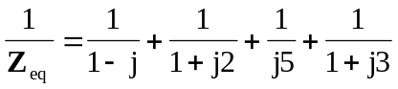
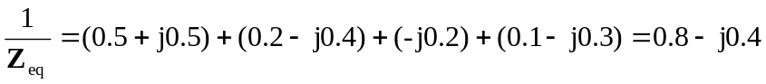
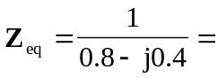 (1 + j0.5) 

